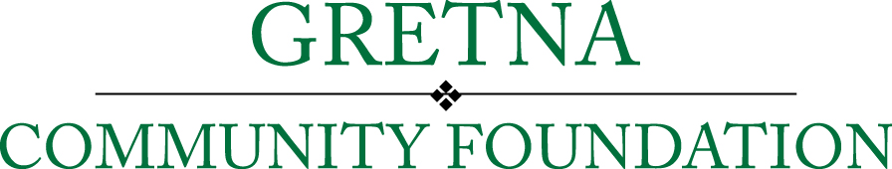
Office Use Only
Date Received:

Grant Application Form

Date:_________________________________________

Legal Name of Organization
Mailing Address
Contact Person
Position/Title
Contact Phone
Contact Email

Authorized Signature (CEO, Executive Director, etc.)
Title
Email
Federal Tax ID#

1) Briefly describe the applicant organization, its programs and population served.

- What is your non-profit’s mission statement?

- What makes your organization unique compared to similar nonprofits? (maximum of 250 words)

- Briefly describe some of your most successful past projects. (maximum of 250 words)

- What challenges does your organization face? (maximum of 250 words)

2)
Total cost of the proposed project/program: | $
Amount requested from Gretna Community Foundation: | $

3)
Funding period: | From: (month/day/year): | To: (month/day/year):

4) Budget for the total project or program for which you are applying for Gretna Community Foundation grant funds. Attach documentation if available. In-kind donations and other grant funding (including federal and state) should be listed.

Sources of funds (list) | Amount of each
Total Revenues | $

Expenses (list) | Amount of each
Total Expenses | $

If the grant request is for a multi-year project, please show the budget for each year.

Please provide additional information that may be helpful in understanding the above budgetary figures.

5) Grant Request Details:

A. PROBLEM/PURPOSE: Describe the project/program, including what it will accomplish, what benefits it will provide and what community need it will meet.

B. IMPLEMENTATION: How will this project be accomplished? By whom, where, when, etc.? Provide numbers and timetable.

C. POPULATION SERVED: How many people will be served or affected by this project and for how long? What percentage of the people served or affected live within the City of Gretna or the Gretna School District?

D. COORDINATION: Who else is addressing this need? Are there any coordination efforts between you and them? How does this project's approach differ from other already established efforts?

E. CONTINUATION: Will this project require continued funding? If so, identify the source of this future funding.

F. SUCCESS: Based on the data in your planning framework, briefly describe how you plan to evaluate the actual results against planned outcomes and outputs. How will you measure the success or sustainability of the grant fund's impact?

G. RECOGNITION: In return for this grant award, how will your organization recognize the Gretna Community Foundation and promote this grant project/program?

